Enriching Social Situational Awareness in Remote Interactions: Insights and Inspirations from Disability Focused Research

Sreekar Krishna, Vineeth Balasubramanian, Sethuraman Panchanathan

Center for Cognitive Ubiquitous Computing (CUbiC)  
Arizona State University  
699 S. Mill Ave, Tempe AZ, USA 85281  
001 (480) 727 3612

[Sreekar.Krishna@asu.edu](mailto:Sreekar.Krishna@asu.edu), [Vineeth.nb@asu.edu](mailto:Vineeth.nb@asu.edu), [Panch@asu.edu](mailto:Panch@asu.edu)

**ABSTRACT**

In this paper we present a new perspective into developing technologies for enriching social presence among remote interaction partners. Inspired by the abilities and limitations faced by people who are disabled during their everyday social interactions, we propose novel portable and wearable technologies that could potentially enrich remote interactions even in audio and video deprived settings. We describe the important challenges faced by people who are disabled during everyday dyadic and group social interactions and correlate them to the challenges faced by participants in remote interactions. With a case study of visually impaired individuals, we demonstrate how assistive technologies developed for social assistance of people who are disabled can help in increasing the social situational awareness, and hence social presence, of remote interaction partners.

**Categories and Subject Descriptors**

H.5.2. Information interfaces and presentation (e.g., HCI): User Interfaces, *Haptic I/O*. K.4.2. Computing Milieux: Computers and Society, *Assistive technologies for persons with disabilities*.

**General Terms**

Algorithms, Measurement, Documentation, Design, Experimentation, Human Factors,

**Keywords**

Socio-Behavioral Computing, Remote Social Interactions, Social Assistive Technology, Human-Centered Multimedia Computing.

# INTRODUCTION

Interpersonal interactions are socially driven exchanges of verbal and non-verbal communicative cues. The essence of humans as social animals is very well exemplified in the way humans interact face-to-face with one another. Even in a brief exchange of eye gaze, humans communicate a lot of information about themselves, while assessing a lot about others around them. Though not much is spoken, plenty is always said. We still do not understand the nature of human communication and why face-to-face interactions are so significant for us. When interactions become remote, no technology is yet able to replace the experience of a face-to-face interaction. Even with the best state-of-the-art multimedia rendering systems, with sophisticated audio, video and touch capabilities, we are not able to reproduce the social presence of communicating in person.

Elegant human communication necessitates a smooth interaction of the sensory, motor and cognitive modules of the brain. The physical separation between interaction partners prevents sufficient information from reaching one or more of these areas thereby diluting the richness of communication experience. A very similar dilution is observed in co-located interaction partners when a sensory, motor or cognitive disability hinders one or more of the interaction partners from receiving, processing and reciprocating to social communicative signals. This is specifically exaggerated when one of the individuals is disabled and the others are not trained to interact with the specific disabled population.

At the Center for Cognitive Ubiquitous Computing (CUbiC), we have been studying social interactions in the disabled population, specifically, the visually impaired population from an assistive technology perspective. In this paper, we share insights and inspirations into everyday social interactions in the disabled population and how they relate to remote interactions across physical boundaries.

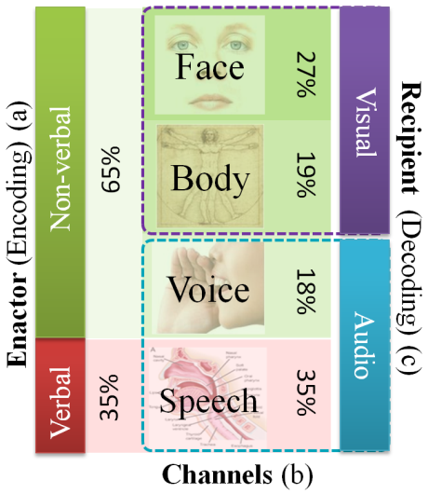

Figure 1. Relative importance of a) verbal vs. non-verbal cues, b) four channels of non-verbal cues, and c) visual vs. audio encoding & decoding of bilateral human interpersonal communicative cues

## Non-Verbal Communication

Human communication involves a complex interplay of verbal and non-verbal cues. Nearly 65% of all human interpersonal communications happen through non-verbal cues [1], which are superimposed on the sensory, motor and vocal communicative reciprocations. In a typical bilateral interpersonal interaction, while speech verbalizes the information, non-verbal cues facilitate an elegant means of delivery, interpretation and exchange of verbal information. For example, eye gaze, iconic body gestures, hand gestures, and prosody provide effective and seamless role play in social interpersonal interactions. In everyday social interactions, people communicate so effortlessly through both verbal and non-verbal cues that they are not cognizant of the complex interplay of their voice, face and body in establishing a smooth communication channel.

### Social Sight and Social Hearing

Of all the non-verbal communication cues, nearly 70% is encoded in visual cues displayed as gestures and mannerisms of the face and body, while the rest is delivered as auditory cues represented as prosody and intonation (See Figure 1; based on the meta-analysis of thin slices of expressive behaviors in humans [2]). People learn to communicate through these non-verbal cues as part of the cultural norms but most of the learning becomes subconscious and requires specialized training to become aware of their manifestations on the face, body and voice. Research has shown that untrained individuals, specifically enactors in dyadic interactions, display various levels of cognitive leakiness (having little or no conscious control) in their non-verbal communication. For example, individuals always tend to display emotions first through their voice before showing it on their body or face. That is, one’s emotional state is leaked first through their voice before they show it in their body mannerism. On the other hand, recipients of these cues decode them continuously from the different channels and can augment one channel with another when there is any form of communicative deprivation. Figure 2 shows the map of leakiness of the three primary non-verbal chancels, face, body and voice with the amount of information encoded in these channels.

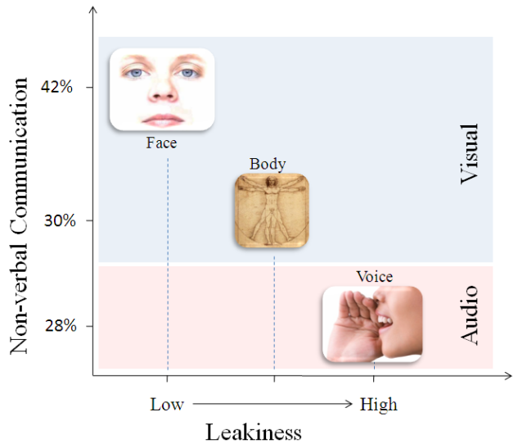

Figure 2. Affect communication through non-verbal channels plotted on two independent axis of the amount of information displayed vs. the leakiness of the channel

### Social Touch

Apart from visual and auditory channels of social stimulation, humans increasingly rely on social touch during interpersonal interactions. For example, hand shake represents an important aspect of social communication conveying confidence, trust, dominance and other important personal and professional skills [3]. Social touch has also been studied by psychologists in the context of emotional gratification. Wetzel [4] demonstrated patron gratification effects through tipping behavior when waitresses touched their patrons. Similar studies have revealed the importance of social touch and how conscious decision making is connected deeply with the human affect system. In the recent years social touch has gained a lot of interest in the area remote interactions [5] [6] to help better understand the nature of social situational awareness in social presence.

# SOCIAL SITUATIONAL AWARENESS

In this paper, we refer to the term Social Situational Awareness (SSA) as the ability of individuals to receive the visual, auditory and touch based non-verbal cues and respond appropriately through their voice, face and/or body (touch and gestures). Figure 3 represents the concept of consuming social cues and reacting accordingly to the needs of social interaction. Social cognition bridges stimulation and reciprocation and allows individuals to interpret and react to the non-verbal cues.

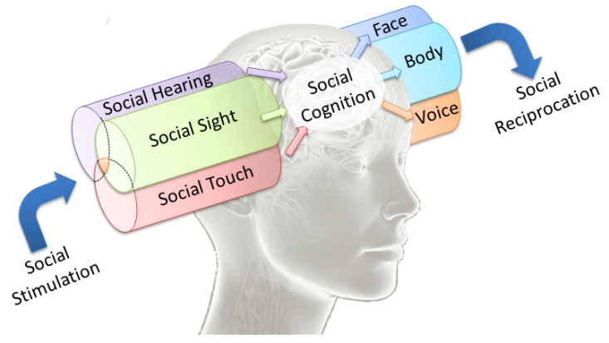

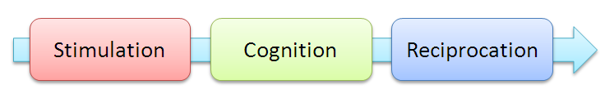

Figure 3: Social Situational Awareness

The Transactional Communication Model [7] suggests that during any face-to-face interaction, the interpretation of the social stimulation and the corresponding social response are under the control of various factors including the culture, physical and emotional state, experience, memory, expectation, self concept and attitude of the individuals involved in the interaction. In order to effectively cognize and react to the social stimulation, it is necessary that individuals be able to receive and synthesize these above factors. Enriching social situational awareness then represents the ability of a mediator (telecommunication technology for remote interactions; social assistive technologies for the disabled population) to allow the social cognition of an individual to have access to the above mentioned factors and thereby evoking appropriate social reciprocation.

## Social Situational Awareness in Everyday Social Interactions

### SSA in Dyadic Interactions:

Human communication theories have studied dyadic or bilateral interaction between individuals as the basis of most communication models. Theories of leadership, conflict and trust base their findings on dyadic interaction primitives where the importance of the various non-verbal cues is heightened due to the one-on-one nature of dyadic interactions. Eye contact, head gestures (nod and shake), body posture (conveying dominance or submissiveness), social touch (hand shake, shoulder pat, hug, etc.), facial expressions and mannerisms (smile, surprise, inquiry, etc.), eye gestures (threatened gaze, inquisitive gaze, etc.) are some of the parameters that are studied closely in dyadic understanding of human bilateral communication [8]. Enriching SSA in dyadic communication thus focuses on appropriate extraction and delivery of communicator’s face, body and voice based behaviors to a remote participant or to a person who is disabled.

### SSA in Group Interactions

Group dynamics refer to the interactions between members of a team assembled together for a common purpose. For example, teams of medical professionals operating on a patient, a professional team meeting for achieving a certain goal, a congressional meeting on regulations, etc. represent groups of individuals with a shared mental model of what needs to be accomplished. Within such groups, communication behaviors play a vital role in determining the dynamics and outcome of the meeting. Zancanaro et. al. [9] and Dong et. al. [10] presented one model of identifying role-play of participants in a group discussion. They identified two distinct categories of roles for the individuals within the group, namely, the socio-emotion roles and the task roles. The socio-emotional roles included the protagonist, attacker, supporter and neutral, and the task roles included the orienteer, seeker, follower and giver. These roles were dependent heavily on the emotional state (affect) of the individuals participating in the group interaction. Good teams are those where individual team members and their leaders are able to compose and coordinate their affect towards a smooth and conflict free group interaction. And effective leaders are those who can read the affect of their group member, make decisions on individual’s roles and steer the group towards effective and successful decisions. Inability to access the affective cues of team members has significant consequences to team leaders leading to unresolved conflict situations and underproductive meetings, or in the worst case, the death of a patient. Thus, enriching SSA in group settings correspond to the extraction and delivery of team’s interaction dynamics (which are in turn modulated in their mutual and group affect) to a remotely located team member or to a co-located individual who is disabled.

In essence, SSA enrichment technologies provide for a richer interaction experience for individuals involved either in a dyadic or group interaction. It is well established that in teams comprising of good communication strategies a shared mental model towards effective decision is achieved faster with little or no emotional stress on the team members. The lack of social awareness can lead to interactions where individuals are not committed cognitively and find it very difficult to focus their attention on the communication. This is true in the case of remote interactions and disability. In this paper, we advocate that the social separation induced by remote interactions in physically separated partners is similar to the social separation resulting from information impoverishment induced by sensory/physical disabilities in co-located interaction partners and propose technologies targeted at enriching social interactions.

## Learning Social Awareness

Figure 3 represents a simple unidirectional model of social stimulation and reciprocation. In reality, social awareness is a continuous feedback learning system where individuals are learning through observing, predicting, enacting and correcting themselves. It is this learning mechanism that allows people to adapt easily from one culture to another with ease – here we refer to term culture in very broadly encompassing work culture, social culture in a new environment and culture of a new team, etc. Figure 4 shows the continuous feedback loop involved in social learning systems, based on the model of human cognition as proposed by Hawkins [11].

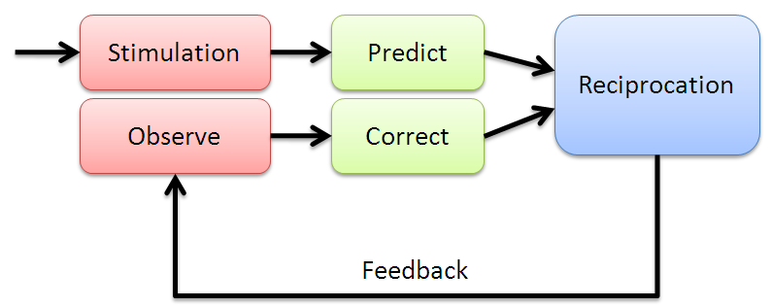

Figure 4. Social learning systems with continuous learning feedback loop

People without disabilities learn social skills from the three different social stimulations (*social sight, social hearing and social touch*) effortlessly. When faced with a new environment, individuals exercise their learned social skills to predict what social actions are appropriate in the setting. Once executed, they observe and assess their counterparts to determine if their new behavior is appropriate or not for the new setting. Such learning continues until their social rule set adapts to the new environment. Psychologists have been studying the nature of learning that happens in individuals who move from Western to Eastern cultures and vice versa. Largely, USA and Japan have been the countries of choice based on their economic equality and cultural diversity [11]. In the West, large body movements and excitement in the voice are considered to be typical and to a large part encouraged as a good social skill. Similar attitudes in the East are considered to be inappropriate in professional settings and to a large extent considered indecent. An individual displaying any such inappropriate mannerisms or gestures will receive social feedback from his counterparts (everyone staring at the individual, reduced interaction with the individual, etc.). Thus, social awareness is a learned set of rules about the environment within which the individual is present and this requires continuous monitoring of the various social channels of stimulation. Deprivation of any one of these channels can in turn affect the ability of the individual to learn social actions and responses that are pertinent to a social situation. Thus, enriching SSA not only offers the means for individuals to make appropriate social decisions, but also cognitively trains them towards effective social judgments.

# DISABILITY AND SOCIAL SITUATIONAL AWARENESS

Figure 5 shows a representational space of the social situational difficulties that maybe faced by individuals having specific disabilities. For example, people who are blind and visually impaired do not have access to visual non-verbal cues like expressions, gestures, mannerisms etc. while people who are hard at hearing could face difficulties understanding the prosody (where prosody encodes the most leakiest of the non-verbal communication channels). The same can be said of the various telecommunication technologies in current use. For example, audio conferencing systems deliver social hearing, but visual and touch based cues are lost. Similarly, current text-to-speech engines are able to communicate verbal aspects of interactions, while the intonations are lost making the deliberation dreary. In this section, we demonstrate, through a case study, the correlations between social interactions in the disabled population and remote team interactions.

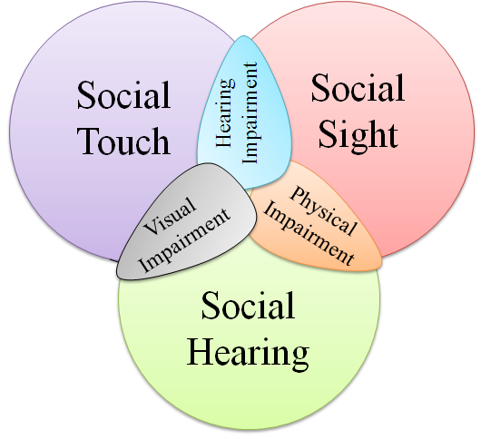

Figure 5. Placement of various disabilities in the Social Awareness space

## Case Study: Social Interactions in the Visually Disabled Population

The visually disabled population finds the lack of access to most forms of non-verbal communication to be an impediment in their everyday interactions. While most persons who are blind or visually impaired eventually make accommodations for the lack of visual information, and lead a healthy personal and professional life, the path towards learning effective accommodations could be positively effected through the use of assistive aids. Specifically, children with visual disabilities find it very difficult to learn social skills while growing amongst sighted peers, leading to social isolation and psychological problems [12]. Social disconnect due to visual disability has also been observed at the college level [13] [14] where students start to learn professional skills and independent living skills.

At CUbiC, two focus group discussions were conducted with people who are blind and visually impaired to understand some of the important needs of this disabled population. Both the groups emphasized the inaccessibility to non-verbal social cues as an important area that has been overlooked by researchers and assistive technologists [15]. Consider a simple form of nonverbal communication: glancing at a watch to signal that it is time to wrap up a meeting. The sighted participants might respond to such a glance automatically, without consciously realizing that this visual information is not accessible to a participant who is blind. Similarly, a sighted person asking a question in a group will use gaze direction and eye contact to indicate to whom the question is directed. Without access to this visual cue, people who are blind might be left wondering whether the question was directed towards them. They can answer immediately (at the risk of feeling foolish if the question was not directed at them) or they can wait to see if anyone else answers (and risk being thought of as rather slow witted).

Following the focus group studies, a systematic analysis of the social interaction assistance needs was carried out with the help of an assistive technology usability expert, who was also blind from a very young age. Eight important areas were identified as critical in providing social assistance to people who are blind and visually impaired. Table 1 presents the eight aspects of face-to-face social interactions that were identified for further analysis.

Table 1. Eight questions that were developed based on focus group studies conducted with people who are blind and visually impaired

|  |  |
| --- | --- |
| **1** | I would like to know if any of my personal mannerisms might interfere with my social interactions with others. |
| **2** | I would like to know what facial expressions others are displaying while I am interacting with them. |
| **3** | When I am standing in a group of people, I would like to know the names of the people around me. |
| **4** | I would like to know what gestures or other body motions people are using while I am interacting with them. |
| **5** | When I am standing in a group of people, I would like to know how many people there are, and where each person is. |
| **6** | When I am standing in a group of people, I would like to know which way each person is facing, and which way they are looking. |
| **7** | I would like to know if the appearance of others has changed (such as the addition of glasses or a new hair-do) since I last saw them. |
| **8** | When I am communicating with other people, I would like to know what others look like. |

In order to understand the importance of the visual social cues shown in Table 1, a web based survey was conducted with 27 participants (16 persons who are blind, 9 with low vision and 2 sighted specialists in the area of visual impairment) who rated the importance of the 8 social needs [16]. The participants responded on a 5 point Likert scale; 5, implying strong agreement, to 1, implying strong disagreement. Figure 6 shows a non-parametric rank average analysis of the participants’ responses in the sequence 1 through 8.

### Discussion of Survey Results

The results from the survey identified certain interesting aspects of social interactions of individuals who are blind and also of the general population. It was found that the visually disabled population was most concerned about how their own body mannerisms were affecting their social interactions. In our observations, we noticed that people who are blind and visually impaired did not display body, face or head based mannerisms that are typical of their sighted counterparts. This relates to the response of the survey participants. Individuals who are blind and visually disabled were deprived of the opportunity to learn the non-verbal cues due to the lack of social visual stimulations. Further, since these individuals could not assess the social feedback (for any of their body, face or head based movements), they appear to have restricted such movements entirely to avoid displaying potentially inappropriate behaviors.

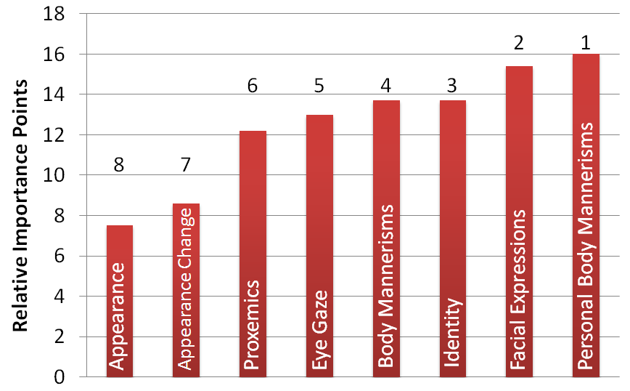

Figure 6. Self report importance (scaled over 100 points) of visual non-verbal cues obtained through an online survey of target population and specialists

The seven other items in Table 1 correspond to the behavior and appearance of the interaction partner. Following their own body mannerisms, these individuals were interested in the facial expressions, body mannerisms, identity, eye gaze, proxemics (location) and appearance of their social interaction partners, in the presented order. This list corresponds very closely to the list of non-verbal cues that are studied by psychologists within the area of human communication [1].

### Relationship with Issues in Remote Interactions

The results of the survey involving people who are visually impaired are not very different from what sighted remote participants expect from their interaction counterparts. An industry survey [17] of 1592 individuals who collaborated remotely, carried out by RW3 CultureWizard – a company focused on improving international collaborations – reported difficulties similar to what was faced by the individuals who are blind. “*Respondents found virtual teams more challenging than face‐to‐face teams in managing conflict (73%), making decisions (69%), and expressing opinions (64%).* *The top five challenges faced during virtual team meetings were insufficient time to build relationships (90%), speed of decision making (80%), different leadership styles (77%), method of decision making (76%), and colleagues who do not participate (75%).*” These results can be correlated to the need for Social Situational Awareness in group settings, specifically one that can promote leadership and personal understanding of each other as indicated in Section 2.1.2.

Further, when the participants were asked about the personal challenges faced during virtual team meetings, they reported “… *inability to read non‐verbal cues (94%), absence of collegiality (85%), difficulty establishing rapport and trust (81%), difficulty seeing the whole picture (77%), reliance on email and telephone (68%), and a sense of isolation (66%).*” Delivering non-verbal cues, establishing trust and rapport, and easing isolation are all derivatives of increasing one’s social connection to their interaction partners, be it remote or face-to-face. Observing people who are disabled and the way they communicate with their co-located partners, it is possible to derive inspirations for novel social mediation technologies. The following subsection discusses one example of how to develop an evidence-based social situational awareness model based on hand shaking in the blind population as an example of social interaction between participants.

Table 2. Survey on the challenges of remote interaction [17].

|  |
| --- |
| **Challenges in virtual teams compared to face-to-face teams** |
|  |
| **Top five challenges faced during virtual team meetings** |
|  |
| **Personal challenges during virtual team meetings** |
|  |

## Evidence-based Understanding of Social Situational Awareness: The Handshake Example

What seems to be a simple act of shaking hands between two individuals is actually a rather complex cognition of sensorimotor events. Two individuals who engage in shaking hands have to first make eye contact, exchange emotional desire to interact (this usually happens through face and body gestures, such as smile and increased upper body movements), determine the exact distance between themselves, move appropriately towards each other maintaining interpersonal distance that are befitting of their cultural setting, engage in shaking hands, and finally, move apart assuming a conversational distance which is invariably wider than the hand shake distance. Verbal exchanges may occur before, during or after the hand shake itself. This example shows the need for sensory (visual senses of face and bodily actions, auditory verbal exchange etc.), perceptual (understanding expressions, social distance between individuals etc.), and cognitive (recognizing the desire to interact, engaging in verbal communication etc.) exchange during everyday social interactions.

People who are blind and visually impaired face numerous challenges when it comes to interactions like hand shake. They are not able to process the visual cues of where someone is standing with respect to themselves (especially in a group setting), they cannot determine if anyone has made an eye contact indicating a motive to interact, and they are not able to determine how far their interaction partners are located and in what direction. Alternately, they mostly initiate a handshake by standing at one place and extending their arm in a handshake posture in the direction where they hear most people conversing, hoping to draw the attention of their sighted counterparts. In dyadic interactions, this situation is apt towards getting the attention of the interaction partner. Unfortunately, when there is a group of individuals who are all interacting among themselves, it may happen that the individual who is blind will not have sufficient information to determine if any of the sighted counterparts has noticed his/her intent to make social contact.

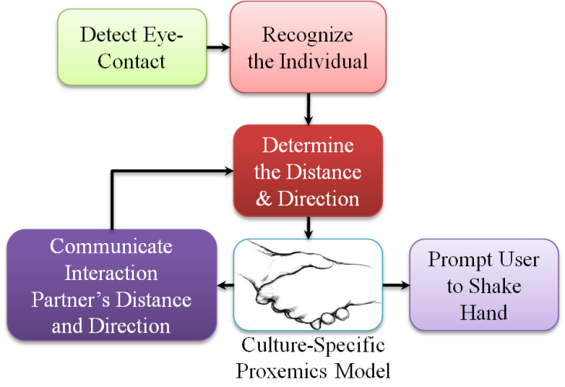

Figure 7: Evidence-based Model for Social Situation Awareness to promote handshake non-verbal cueing in the visually impaired and blind population.

Figure 7 represents an evidence-based model of delivering social situational awareness to an individual who is blind such that he/she can carry out a handshake social interaction amidst a group of sighted individuals. Note that the Proxemics Model presented in the figure refers to the interpersonal spaces that people occupy on a day-to-day basis and it is heavily influenced by the culture where one resides [18]. Section 5.1 will later describe one implementation of this model for delivering social cues to people who are visually impaired and blind. We plan to study such evidence-based models for developing assistive technologies that can communicate important non-verbal cues.

# THE PERILS OF EXCESS TECHNOLOGIES - INSIGHTS FROM DISABILITY STUDIES

For over three decades, Virtual Reality (VR) technologies have been focused on the increasing social presence in telecommunication technologies through immersive environments. These systems have relied heavily on increased animations and avatar-based rendering for increasing the richness of remote interactions. But research is showing that there is an increased aversion to overly animated virtual environments [19] as they tend to cognitively overload the participants in the virtual environment. Further, growing number of research experiments is revealing the need to improve not the form but the behavior of the avatars [20]. Imparting realistic behaviors for the avatars require the understanding of the social norms within which a certain user population operates. Such norms can be extracted through the evidence-based analyses of social interactions. In working with people who are blind and visually impaired, we have discovered important needs for users, disabled or otherwise, that act as constraints within which new technologies will be received. These can be seen as important design requirements that need to be met when it comes to developing technologies that enhance social interactions.

## Sensory and Cognitive Overload

The classic problem with excessive technology is the overloading of the sensory or cognitive capabilities of the humans. Especially in virtual environments, people face a lot of visual overload - possibly due to the attention mechanism of the human visual system not being able to operate in overly rendered environments – causing weak functional engagement with the task at hand [21]. Until recently, most researchers and technologists resorted to auditory modality when information has to be delivered to persons with visual disabilities; but there is a growing discomfort amongst the target population towards overloading their auditory channel. People with visual disabilities have a natural tendency to accommodate for the lack of the visual sensory channel by relying on hearing. For example, with the aid of ambient noise in a room, they can gauge approximately the size of a room. Thus, when designing devices aimed at social assistance, one needs to carefully consider how to deliver the high bandwidth information generated during social interactions like gestures, mannerisms, etc. without overloading the sensory or cognitive capabilities of the user.

## Socially Acceptable Technologies

Technologies developed for social assistance should allow seamless and discrete embodiment of the various sensors and actuators making sure that the device itself does not become a social distraction. VR technologies are bulky and cumbersome when considered for interactions with co-located partners. This restricts VR technologies to one-to-many interactions (one person in the VR interacting with other remotely located partners), while being restrictive for many-to-many interactions (few people in one place interacting with few remotely located communicators). The technologies developed for enhancing user experience should not hinder the normal social interactions of the user. Rana and Picard developed a device called Self Cam [22], which provides explicit feedback to people with Autism Spectrum Disorder (ASD). The system employs a wearable, self-directed camera that is worn on the users own shoulder to capture the user’s facial expressions. The system attempts to categorize the facial expressions of the user during social interactions to evaluate the social interaction performance of the ASD user. Unfortunately, the technology does not take into account the social implication of the assistive technology itself. Since the technology is being developed to address social interactions, it is important to take into account the social artifacts of such technology. A device that has unnatural extensions could become more of a social distraction for both the participants and users than serve as an aid. The case is the same when it comes to remote social interaction aids. Technologies that are overly and awkwardly consuming of the user will have little or no acceptance in the user community

## Wearable technologies

The number of technologies that people interact on a day-to-day basis has been continuously increasing over the past decade. This increase in the number of *necessary* technologies calls for portable and wearable devices that are less cumbersome and integrate into everyday clothing. People with disabilities functionally require additional technologies compared to the general population. For example, people who are blind tend to use note takers, color detectors, bar code scanners, reading devices, navigational devices, etc. These individuals are therefore not keen on adding other devices and technologies. Sinohara et. al. [13], in their interactions with a blind college student found that she prefers to have an integrated portable solution to assistive devices that could combine functionalities. This desire to have fewer devices with greater functionality is also becoming prevalent among the general population. VR systems that are bulky and large deviate are not likely to garner wide acceptance. While Cisco Systems’ TelePresence® is capable of delivering seamless many-to-many remote interactions, the technology is not widely applicable due to the need for expensive equipment, installation and lack of portability of the system. Social interaction assistance systems should target affordability, portability and wearability to ensure broader acceptance by its users.

# SOCIAL SITUATIONAL AWARENESS ENRICHMENT TECHNOLOGIES

In this section, we describe some of the technologies that have been developed at CUbiC towards enhancing the social interactions of people who are blind and visually impaired. These technologies take into account the three concepts of user acceptability described above. Following the description of each technology, we propose how they can be adapted for use in remote interaction situations either as augmentation to existing VR technologies or as stand-alone social interaction enrichment tools.

## Social Interaction Assistant

The social interaction assistant is mostly based on the evidence-based model of social situational awareness that was developed in Section 3.2 (Figure 7). This assistive technology is focused on providing the users who are blind and visually impaired with social interpersonal positional data (distance and direction) on their interaction partners. This allows the user to be aware of the social distances (Proxemics) during social interactions and thereby become cognizant of the various cultural variants of social distances.

The device consists of a pair of glasses that has a 1.3 Megapixel CMOS camera mounted on the nose bridge of the camera (Figure 8(a)) and the device communicates all the captured video to a PDA-like computing element. The video is analyzed in real-time to detect faces that may be present in the scene. The face detection is based on the popular Viola-Jones algorithm [23]. The face detection algorithm provides the location the size of the detected face region(s) depending on how many ever people may be standing in front of the user. We use this size information for determining the distance between the user and the interaction partner.

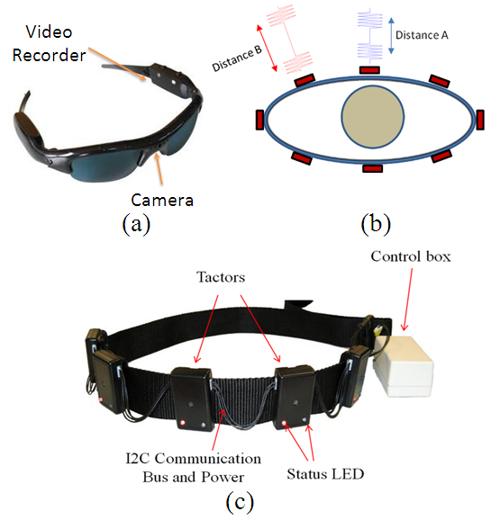

Figure 8. (a) Camera glasses used as the input to the social interaction assistant, (b) Communicating situational data of the interaction partner through vibrations, (c) The haptic belt situational information delivery system.

The American Proxemics, as defined by Edward Hall and other socio-behavioral psychologists, proposes eight distinct interpersonal distances that influence the interaction between individuals, 1) Intimate Distance (Close Phase): 0-6 inches; 2) Intimate Distance (Far Phase): 6-18 inches; 3) Personal Distance (Close Phase): 1.5-2.5 feet; 4) Personal Distance (Far Phase): 2.5-4 feet; 5) Social Distance (Close Phase): 4-7 feet; 6) Social Distance (Far Phase): 7-12 feet; 7) Public Distance (Close Phase): 12-25 feet; 8) Public Distance (Far Phase): 25 feet or more.

A Naive Bayesian Classifier with Gaussian posterior probability densities were used for classifying the 7 interpersonal distance classes (we combined zone 1 and 2 into Intimate space) parameterized over the size of the face image. Thus given any detected face and its corresponding size *s*, a posterior probability P(*Zi/s*) of the interaction partner present in zone *Zi* can be obtained as

Figure 8(b) conveys the idea of communicating the presence of two individuals at two different directions and at two different distances.

All the extracted information had to be delivered to the user without hindering their typical hearing as this would interfere with their ability to assess the social situation. To this end, we developed a vibrotactile situational awareness device, termed as the haptic belt. The belt consists of a set of vibrators that can be located around the waist of the user as shown in Figure 8(c). Please see [24][25][26] for further details on the construction of the haptic belt and results from human factors experiments in conveying distance and direction information using the belt.

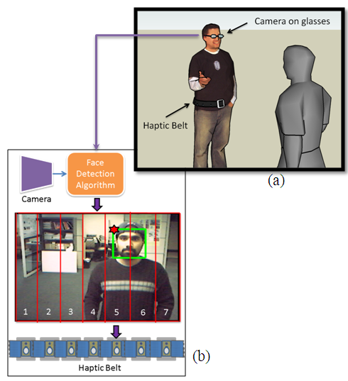

Figure 9. (a) Typical use of the social interaction assistant, a third person perspective on the use case scenario, (b) An example of face detection being translated to vibrations on the haptic belt.

Figure 9 shows the typical use case scenario of the social interaction assistant. When the user who is blind encounters an individual who looks at the user, the face detection algorithm detects where the person is on the image as shown in Figure 9 (b). Based on the location of the face on the image, a corresponding vibrator is selected for communicating the data. Also, based on the size of the face, an interpersonal interaction zone is selected through the Naive Bayesian Classifier. The distance information is communicated as pulses of vibration rhythms as described in [26] and shown pictorially in Figure 8(b).

### Social Interaction Assistance in Remote Interactions

In a remote interaction setting, one important social situational cue that is lacking is the information that someone has left the meeting or that someone has just joined the meeting. This situation is very similar to the scenario of an individual who is blind not being able to know which co-located interaction partner left the meeting or if someone joined the meeting. Also, an important aspect of face-to-face interactions is the ability of have personal interactions between individuals without disturbing the overall meeting setting. From Table 2, survey participants addressed these issues through their inability to develop personal relationships, rapport and trust. Technologies like the haptic belt can offer means of creating a sense of virtual desk where individuals could get the indication of who is sitting next to them in the virtual meeting. It is possible to indicate thorough vibrotactile cueing if someone has left the meeting or if someone joined the meeting. Further, with proper augmentations, it is possible to enable personalized interactions between meeting participants without them disturbing the others. This could potentially help build means for personal relationships between individuals which is otherwise not possible in the current settings.

## Dyadic Interaction Assistant

Dyadic interactions represent a large portion of social interactions between individuals; and during dyadic interactions, it is very important to assess the communicator’s face, head and body-based gestures and mannerisms. As presented in Figure 2, the face captures the largest portion of the non-verbal cues and the current implementation of the dyadic interaction assistant focuses on the interaction partner’s face (and head). The dyadic interaction assistant is to convey important facial and head mannerisms of the interaction partner that might correlate to communicative gestures like head nod, head shake, doubt, anger, frustration, happiness, interest, etc. See Figure 10 for a typical dyadic interaction setting. The device incorporates an automated table top face tracker which acts as the input to the system while allowing any extracted data to be delivered on a wearable haptic display called the Haptic Glove.

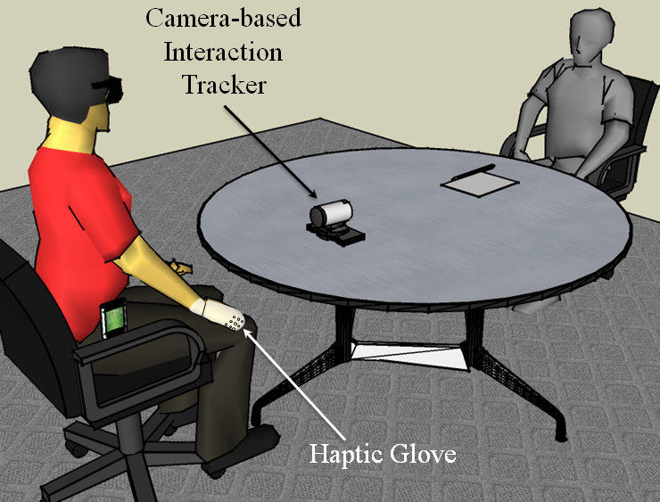

Figure 10. Dyadic Social Situation Awareness Assistant

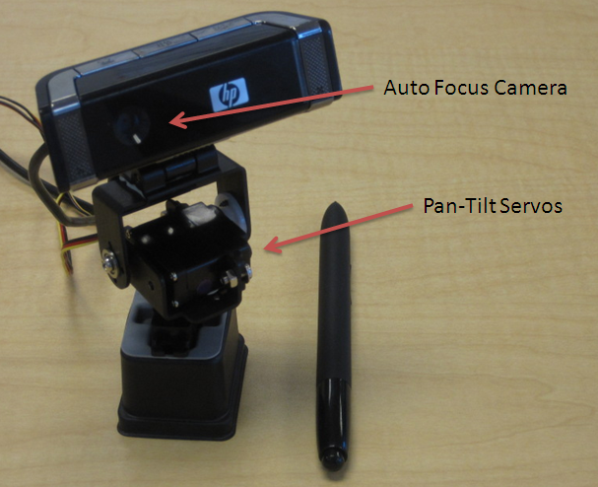

Figure 11. Face tracker with an autofocus camera and a micro pan-tilt mechanism.

The dyadic interaction assistant was designed to be a compact device that can be carried into meetings where an individual who is blind or visually impaired could place it in front of his/her interaction partner. The device, as shown in Figure 11, consists of a micro pan-tilt mechanism that is controlled from a PDA like computing platform. Real-time face detection (as explained in the previous section) tracks the face of the interaction partner and captures only the face image for further processing. We use the FaceAPI®, a commercially available facial feature tracking package to determine the locations of all the facial features including eyelids, eye brows and the mouth. Figure 12 shows a typical output of the FaceAPI software.

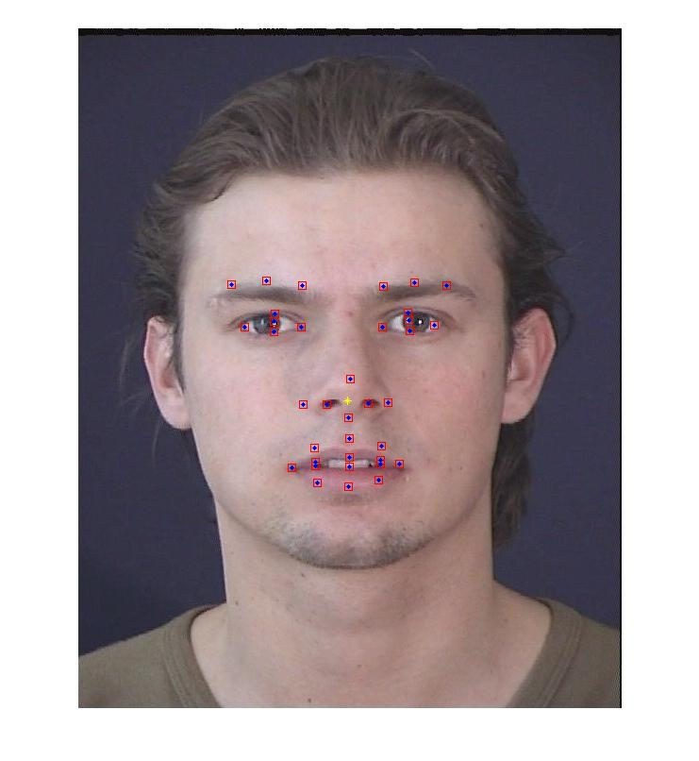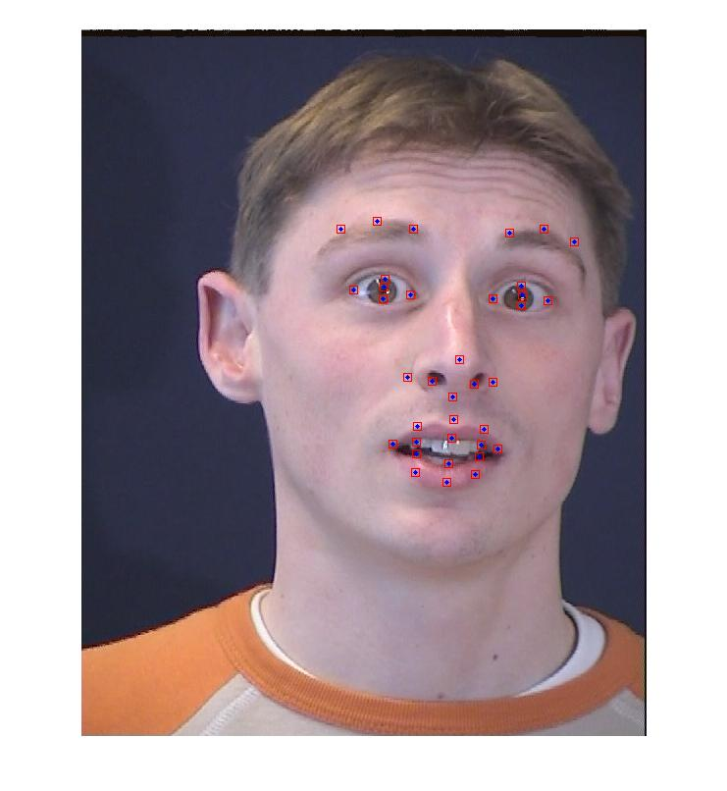

Figure 12. FaceAPI® facial feature tracking software output.

The current implementation of the dyadic interaction assistant distinguishes the 6 basic expressions of happy, anger, sad, surprise, fear and disgust from the neutral face. The output of the facial feature tracker (which is 76 dimensional data consisting of the (*x,y*) coordinates of 38 facial fiducials) was used to train a decision stump for classifying the seven facial expressions.

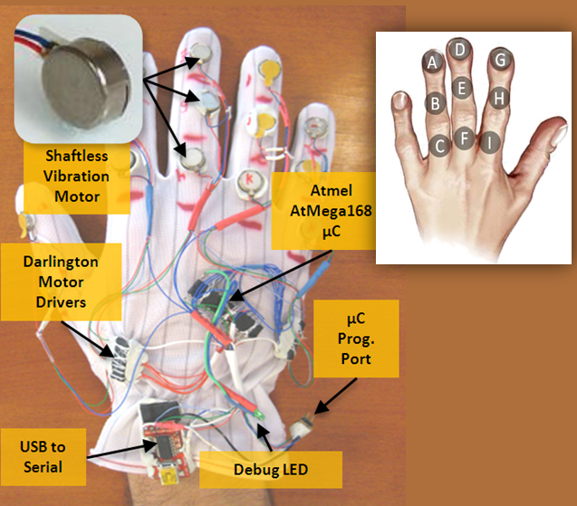

Figure 13. The Haptic Glove.

Delivering dynamically changing non-verbal communication cues is a challenging problem due to the high bandwidth of data that is generated during typical social interactions. For instance, the human face is very dynamic when it comes to displaying facial expressions and mannerisms. Subtle movements in the facial features can convey very different information altogether. Slight opening of the eyelids can convey confusion or interest, whereas a slight closing of the eye lids conveys anger or doubt. Thus, the human face can be considered to be a very high bandwidth information stream, where careful design considerations need to be taken into account if this data has to be encoded optimally and effectively through other modalities. To this end, we designed and developed a haptic vibrotactile glove that can communicate the 7 basic expressions generated from the decision stump. The details of the construction and reasons for the vibrotactile encoding can be found in [27]. Figure 13 shows the glove and Figure 14 shows the spatio-temporal vibration patterns that were used in communicating the facial expressions.

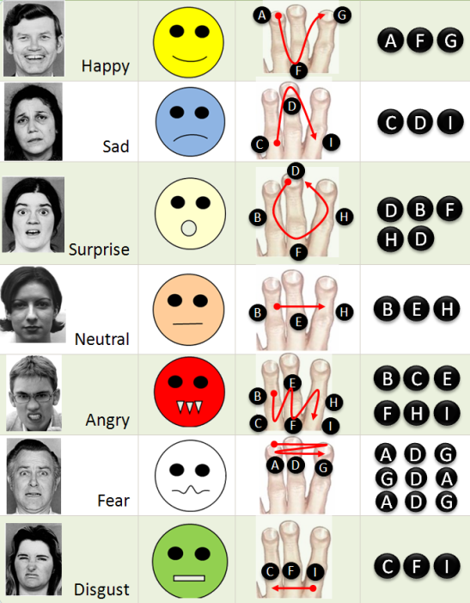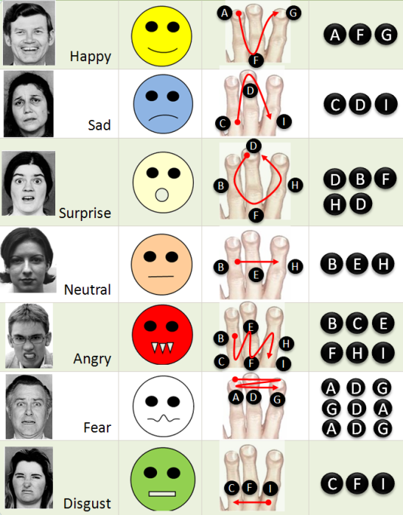

Figure 14. The Vibrotactile encodings on the Haptic Glove for conveying facial expressions.

### Dyadic Interaction Assistance in Remote Interactions

From Table 2, the most important personal challenge that remote interaction participants face is their inability to access the non-verbal cues of their interaction partners. The report [17] concludes that the inability to access non-verbal cues of the interaction partner is one of the most important challenges in remote interactions. While VR technologies are focusing on delivering these non-verbal cues through rich avatar based interactions, a lot of research is needed in understanding how to deliver non-verbal cues in a portable setting without occupying the audio-visual medium of the user all the time. Such portable interaction enrichment technologies will find use in conjunction with current cellular phones, which are the largest medium through which people engage in remote communication these days. To this end, the dyadic interaction assistant presented above delivers a technology that can offer access to facial expressions in a vision deprived setting through the use of vibrotactile stimulations.

# CONCLUSION & FUTURE WORK

In this paper, we discussed how social situational awareness is an important aspect of interpersonal interactions and described new technologies that could enrich the social presence among remote participants. Inspired by the population that is visually impaired, we demonstrated two technologies that are portable and wearable, and can provide access to important non-verbal social cues like interpersonal positions and facial expressions through a non-visual medium. Work is in progress to develop embodied solutions that can extract and deliver body based non-verbal gestures and mannerisms. At CUbiC, we are also focused on developing technologies that can provide a faithful reproduction of all non-verbal cues to the users who are disabled, thereby enabling them to learn and reciprocate these cues within new cultural settings.

# REFERENCES

[1] M.L. Knapp and J.A. Hall, *Nonverbal Communication in Human Interaction*, Harcourt College Pub, 1996.

[2] N. Ambady and R. Rosenthal, “Thin Slices of Expressive behavior as Predictors of Interpersonal Consequences : a Meta-Analysis,” *Psychological Bulletin*, vol. 111, 1992, pp. 274, 256.

[3] J. Burgoon, D. Buller, J. Hale, and M. Turck, “Relational Messages Associated with Nonverbal Behaviors,” *Human Communication Research*, vol. 10, 1984, pp. 351-378.

[4] C. Wetzel, “The Midas Touch: The Effects of Interpersonal Touch on Restaurant Tipping,” *Personality and Social Psychology Bulletin*, vol. 10, 1984, pp. 512-517.

[5] A. Haans and W. IJsselsteijn, “Mediated social touch: a review of current research and future directions,” *Virtual Real.*, vol. 9, 2006, pp. 149-159.

[6] J. Bailenson and N. Yee, “Virtual interpersonal touch: Haptic interaction and copresence in collaborative virtual environments,” *Multimedia Tools and Applications*, vol. 37, Mar. 2008, pp. 5-14.

[7] A.J. Sameroff and M.J. Chandler, “Reproductive risk and the continuum of caretaker casualty,” *Review of Child Development Research*, F.D. Horowitz, Ed., Chicago: University of Chicago Press, 1975.

[8] U. Altmann, R. Hermkes, and L. Alisch, “Analysis of Nonverbal Involvement in Dyadic Interactions,” *Verbal and Nonverbal Communication Behaviours*, 2007, pp. 37-50.

[9] M. Zancanaro, B. Lepri, and F. Pianesi, “Automatic detection of group functional roles in face to face interactions,” Banff, Alberta, Canada: ACM, 2006, pp. 28-34.

[10] W. Dong, B. Lepri, A. Cappelletti, A.S. Pentland, F. Pianesi, and M. Zancanaro, “Using the influence model to recognize functional roles in meetings,” *Proceedings of the 9th international conference on Multimodal interfaces*, Nagoya, Aichi, Japan: ACM, 2007, pp. 271-278.

[11] E. Rogers, W. Hart, and Y. Miike, “Edward T. Hall and the History of Intercultural Communication: The United States and Japan,” *Keio Communication Review*, vol. 24, 2002, pp. 26, 3.

[12] D. Jindal-Snape, “Generalization and Maintenance of Social Skills of Children with Visual Impairments: Self-evaluation and the Role of Feedback,” *Journal of Visual Impairment & Blindness*, vol. 98, 2004, pp. 470-483.

[13] K. Shinohara and J. Tenenberg, “Observing Sara: a case study of a blind person's interactions with technology,” *Proceedings of the 9th international ACM SIGACCESS conference on Computers and accessibility*, Tempe, Arizona, USA: ACM, 2007, pp. 171-178.

[14] K. Shinohara and J. Tenenberg, “A blind person's interactions with technology,” *Commun. ACM*, vol. 52, 2009, pp. 58-66.

[15] S. Krishna, V. Balasubramanian, J. Black, and S. Panchanathan, “Person-Specific Characteristic Feature Selection for Face Recognition,” *Biometrics: Theory, Methods, and Applications (IEEE Press Series on Computational Intelligence)*, N.V. Boulgoris, K.N. Plataniotis, and E. Micheli-Tzanakou, Eds., Wiley-IEEE Press, 2009, pp. 113-142.

[16] S. Krishna, D. colbry, J. Black, V. Balasubramanian, and S. Panchanathan, “A Systematic Requirements Analysis and Development of an Assistive Device to Enhance the Social Interaction of People Who are Blind or Visually Impaired,” *Workshop on Computer Vision Applications for the Visually Impaired*, Marseille, France: 2008.

[17] C. Solomon, *The Challenges of Working in Virtual Teams: Virtual Teams Survey Report 2010*, New York, NY: RW3 CultureWizard, 2010.

[18] E.T. Hall, “A System for the Notation of Proxemic Behavior,” *American Anthropologist*, vol. 65, Oct. 1963, pp. 1003-1026.

[19] C.L. Hoyt, J. Blascovich, and K.R. Swinth, “Social Inhibition in Immersive Virtual Environments,” *Presence: Teleoperators and Virtual Environments*, vol. 12, Apr. 2003, pp. 183-195.

[20] J.N. Bailenson, N. Yee, D. Merget, and R. Schroeder, “The Effect of Behavioral Realism and Form Realism of Real-Time Avatar Faces on Verbal Disclosure, Nonverbal Disclosure, Emotion Recognition, and Copresence in Dyadic Interaction,” *Presence: Teleoperators and Virtual Environments*, vol. 15, 2006, pp. 359-372.

[21] C.J. Chen and W.M.F.W. Ismail, “Guiding Exploration Through Three-Dimensional Virtual Environments: A Cognitive Load Reduction Approach,” *Journal of Interactive Learning Research*, vol. 19, pp. 579-596.

[22] A. Teeters, R.E. Kaliouby, and R. Picard, “Self-Cam: feedback from what would be your social partner,” *ACM SIGGRAPH 2006 Research posters*, Boston, Massachusetts: ACM, 2006, p. 138.

[23] P. Viola and M.J. Jones, “Robust Real-Time Face Detection,” *Int. J. Comput. Vision*, vol. 57, 2004, pp. 137-154.

[24] T. McDaniel, S. Krishna, V. Balasubramanian, D. Colbry, and S. Panchanathan, “Using a haptic belt to convey non-verbal communication cues during social interactions to individuals who are blind,” *Haptic Audio visual Environments and Games, 2008. HAVE 2008. IEEE International Workshop on*, 2008, pp. 13-18.

[25] N. Edwards, J. Rosenthal, D. Molbery, J. Lindsey, K. Blair, T. McDaniel, S. Krishna, and S. Panchanathan, “A Pragmatic Approach to the Design and Implementation of a Vibrotactile Belt and its Applications,” Italy: 2009.

[26] S. Krishna, T. McDaniel, and S. Panchanathan, “Haptic Belt for Delivering Nonverbal Communication Cues to People who are Blind or Visually Impaired,” *25th Annual International Technology & Persons with Disabilities*, Los Angeles, CA: 2009.

[27] T.L. McDaniel, S. Krishna, D. Colbry, and S. Panchanathan, “Using tactile rhythm to convey interpersonal distances to individuals who are blind,” *Proceedings of the 27th international conference extended abstracts on Human factors in computing systems*, Boston, MA, USA: ACM, 2009, pp. 4669-4674.

[28] S. Krishna, S. Bala, T. McDaniel, S. McGuire, and S. Panchanathan, “VibroGlove: an assistive technology aid for conveying facial expressions,” *Proceedings of the 28th of the international conference extended abstracts on Human factors in computing systems*, Atlanta, Georgia, USA: ACM, 2010, pp. 3637-3642.